Title: | Window Lifter  SW Component

History
Issue status  (Index) | Maturity/Date  (draft/invalid/valid)  (dd-mmm-yyyy) | Author  Department | Check/Release  Department | Description
1.0 | Draft  29-Jul-2015 | Hector Cuellar | Arlette | Creation of the document

Table of Contents
1 Purpose 3
2 Definitions and abbreviations 3
3 Realization constraints and targets 3
4 SW Conceptual design 4
5 SW Component internal breakdown 4
5.1 Functional Decomposition 5
5.2 Function T_ULONG main(void) 6
5.3 Function void control_500microseconds(void) 7
5.4 Function void check_button_up(void) 8
5.5 Function void check_button_down(void) 9
5.6 Function void check_button_antipinch(void) 10
5.7 Function void turnOnLeds(void) 11
5.8 Function void turnOffLeds(void) 12
5.9 Function void turnLeds(T_UBYTE lub_led, T_UBYTE lub_mode) 13

Purpose
Window lifter is the module responsible to control the window movement in a car. For this software design the window has to be emulated using a 10 led bar where emulated the two movements in a window (up and down).Also it emulated a movement of security called anti-pinch.
Anti pinch is a feature than prevents accidents between window and some human body parts like arms, hands, head, etc.

Definitions and abbreviations
Definitions

Window lifter  Anti pinch | It is the module responsible to control the window movement  It is a functionality of the window lifter module. It prevents accidents between window and some human body parts

Abbreviations

PIT Periodic Interrupt Timer
GPIO General Purpose Input Output
CES Continental Engineering Services
References
N° | Document name | Reference
1  2 | Window lifter requirements  Traceability Matrix

Realization constraints and targets

Window lifter has to be emulated using a 10 led bar of red color, and the movement of the window has to be simulated turning on/off the LEDS where each transition between each turning on/off LED shall be 400 msec.
The up movement will be represented by a LED blue color and the down movement will be represented by a LED green color.
The module has to be able to detect fail button press. For to consider as valid one button press the button has to be pressed at least 10 milliseconds and button combination has to be considered as invalid.
If the button up is keeping pressed more of 500 milliseconds, the window will close while the button is keeping pressed, in the case that the button up is keeping pressed less of 500 milliseconds the window will close automatically. Those features is the same for the down button.
The module has a security feature named anti-pinch that prevents accidents between window and some human body parts. Anti-pinch button press has to follow the same characteristics than up and down buttons for valid press.
The signal anti-pinch just can be considered as valid when the movement is up. If this signal is valid then the module has to stop the up movement and the down the window until the window get totally open. After that the module has to ignore during 5 seconds all button press.

SW Conceptual design

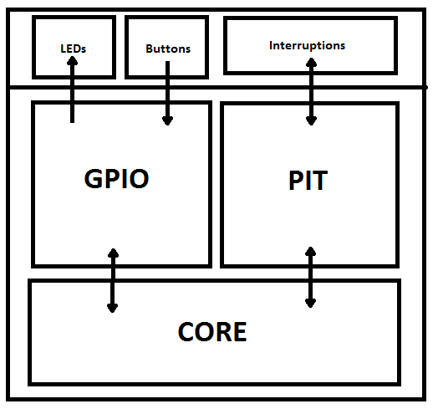

SW Component internal breakdown
Window lifter will be composed for several modules:
- One main module that initialize the GPIO and the PIT and It takes of control the interruptions
- Other module that control to the modules that control the buttons
- A module that control all events in the button up and the states caused by the button up
- A module that control all events in the button down and the states caused by the button down
- A module that control all events in the button anti-pinch and the states caused by the button anti-pinch
- A module that control the time of transaction of turn on in each LED
- A module that control the time of transaction of turn off in each LED
- A small module that turn on/off a specific LED

Functional Decomposition

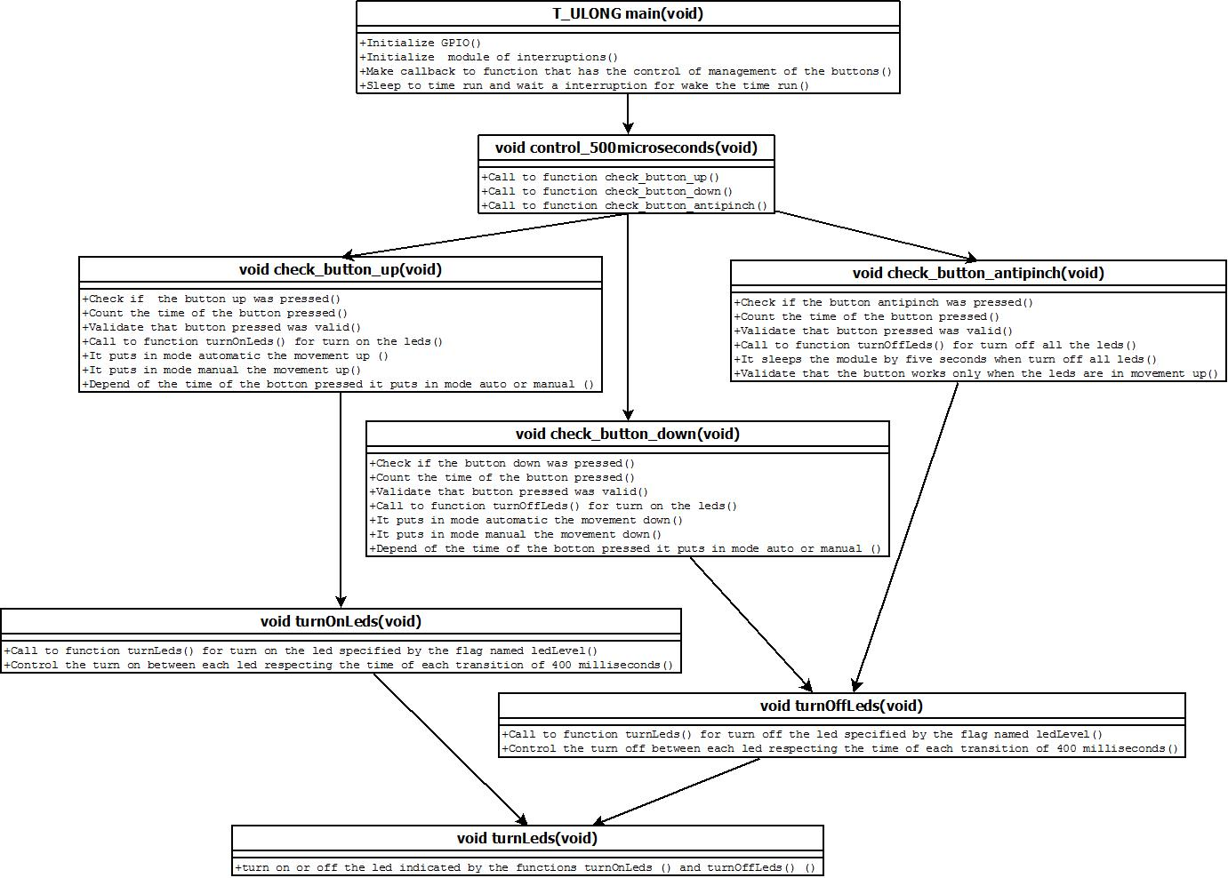
Function Description and Dynamic Behavior

Function T_ULONG main(void)

Description | It initialize the GPIO and PIT, also it call to function that control the button events
Parameter 1  <input| output| inout> | Void
Parameter 2..n | Void
Return Value | Void
Precondition | This function is call when start the module
Post condition
Error Conditions

Dynamic Behavior

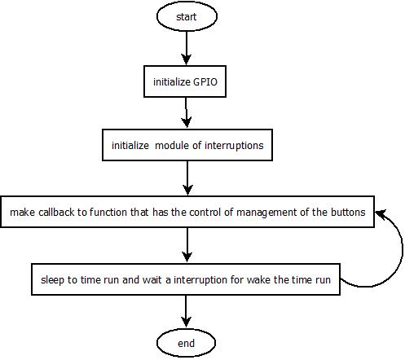

Function void control_500microseconds(void)
Description | This function controls the calls to functions that control an event in a specific button.
Parameter 1  <input| output| inout> | Void
Parameter 2..n | Void
Return Value | Void
Precondition | It is called each 500 microseconds.
Post condition
Error Conditions

Dynamic Behavior

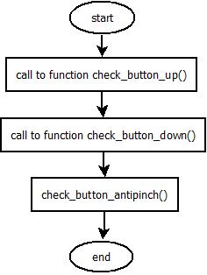

Function void check_button_up(void)
Description | It controls the events in button up and the states caused by this button.
Parameter 1  <input| output| inout> | Void
Parameter 2..n | Void
Return Value | Void
Precondition | This function is called by the function control_500microseconds(void)
Post condition
Error Conditions

Dynamic Behavior
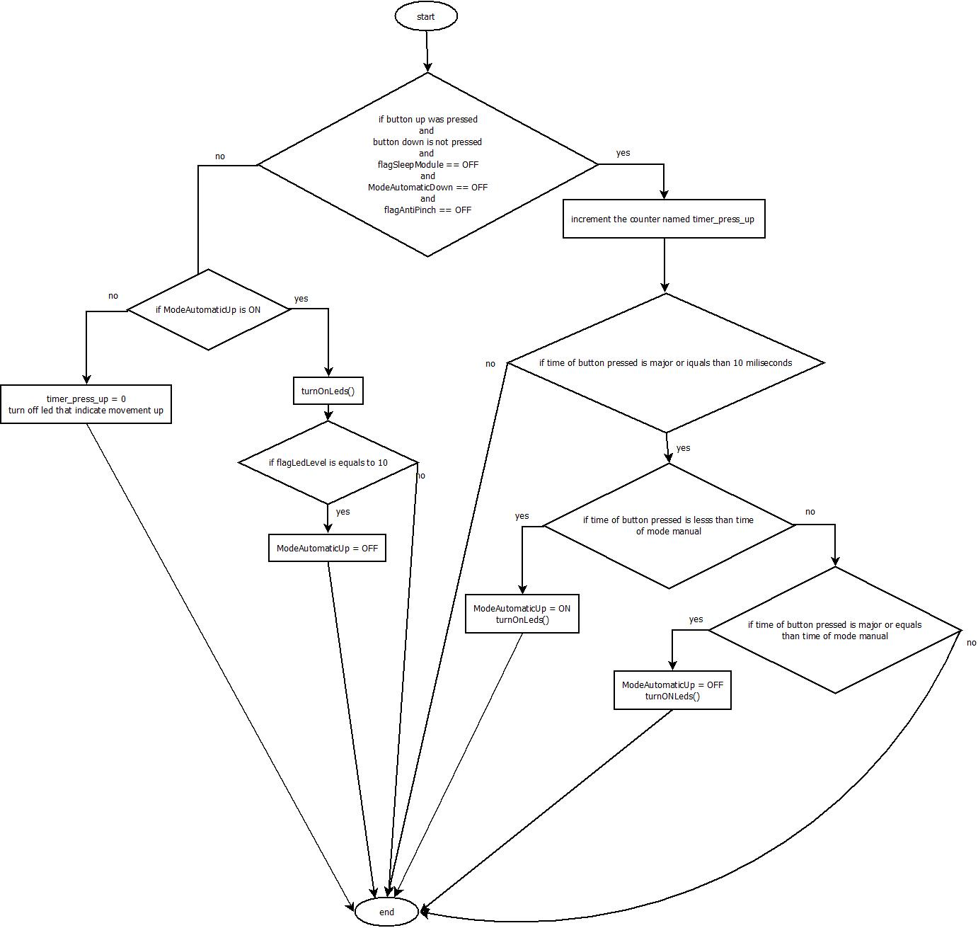

Function void check_button_down(void)
Description | It controls the events in button down and the states caused by this button.
Parameter 1  <input| output| inout> | Void
Parameter 2..n | Void
Return Value | Void
Precondition | This function is called by the function control_500microseconds(void)
Post condition
Error Conditions

Dynamic Behavior
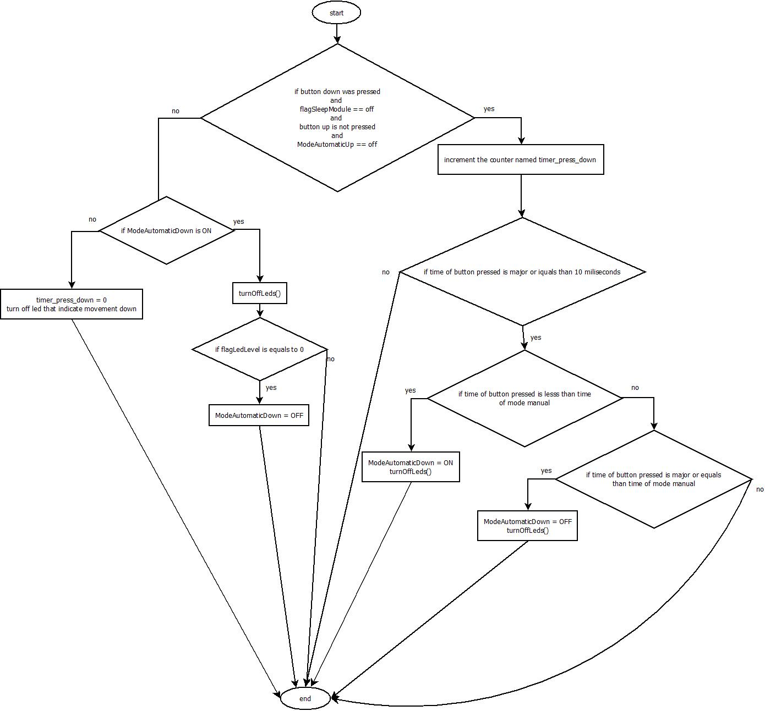

Function void check_button_antipinch(void)
Description | It controls the events in button anti pinch and the states caused by this button.
Parameter 1  <input| output| inout> | Void
Parameter 2..n | Void
Return Value | Void
Precondition | This function is called by the function control_500microseconds(void)
Post condition
Error Conditions

Dynamic Behavior
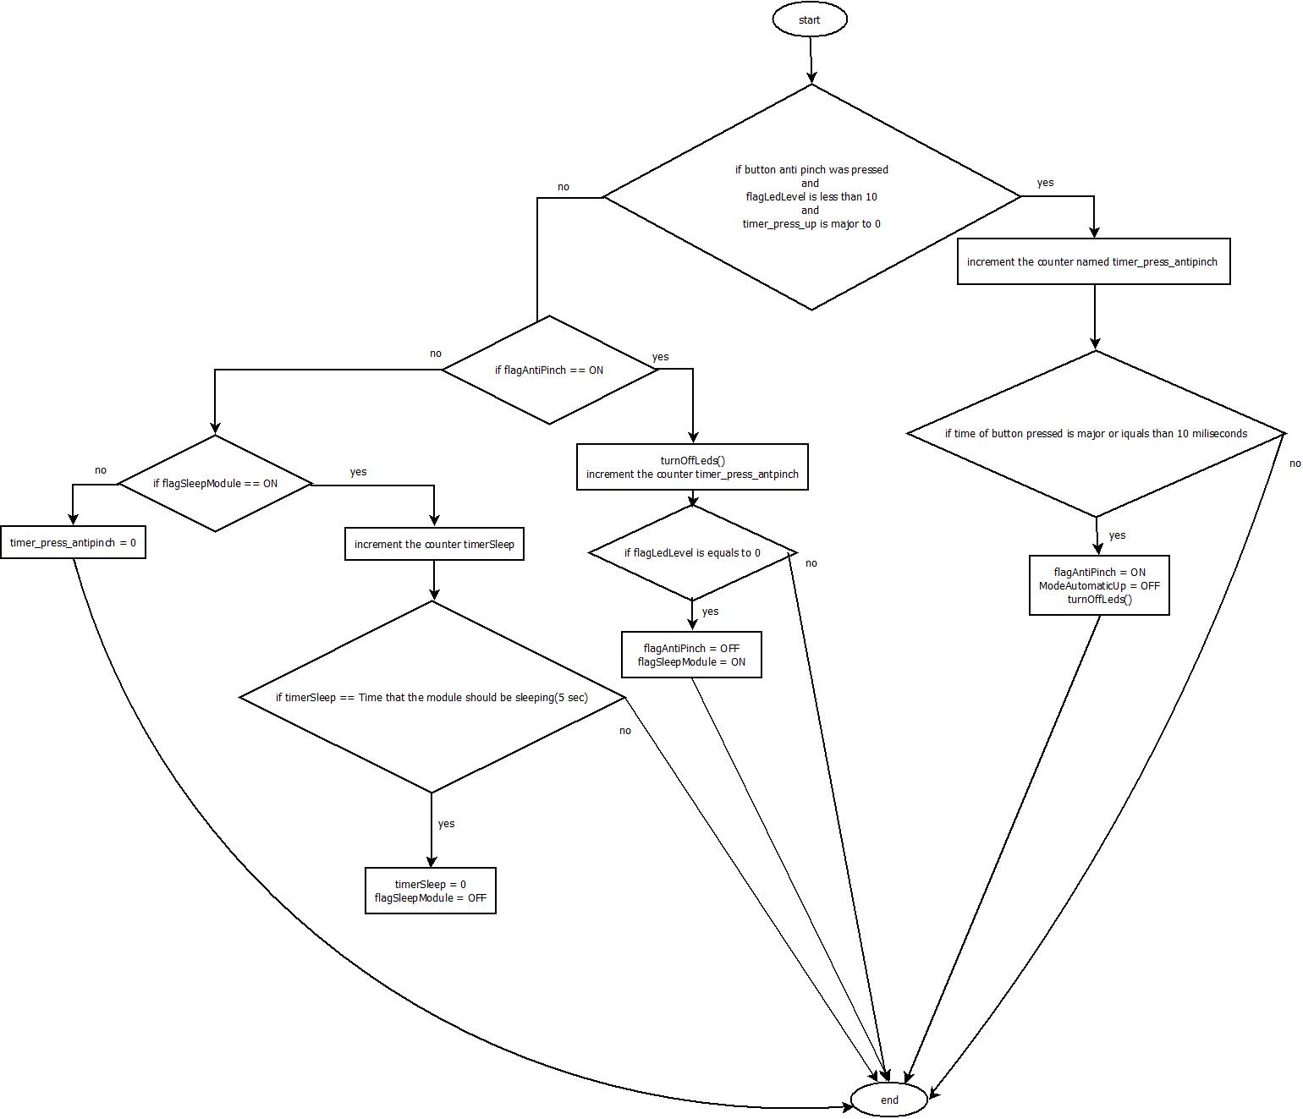

Function void turnOnLeds(void)
Description | It controls the turn on between each led respecting the time of each transition of 400 milliseconds
Parameter 1  <input| output| inout> | Void
Parameter 2..n | Void
Return Value | Void
Precondition | This function is called by the function check_button_up()
Post condition
Error Conditions

Dynamic Behavior
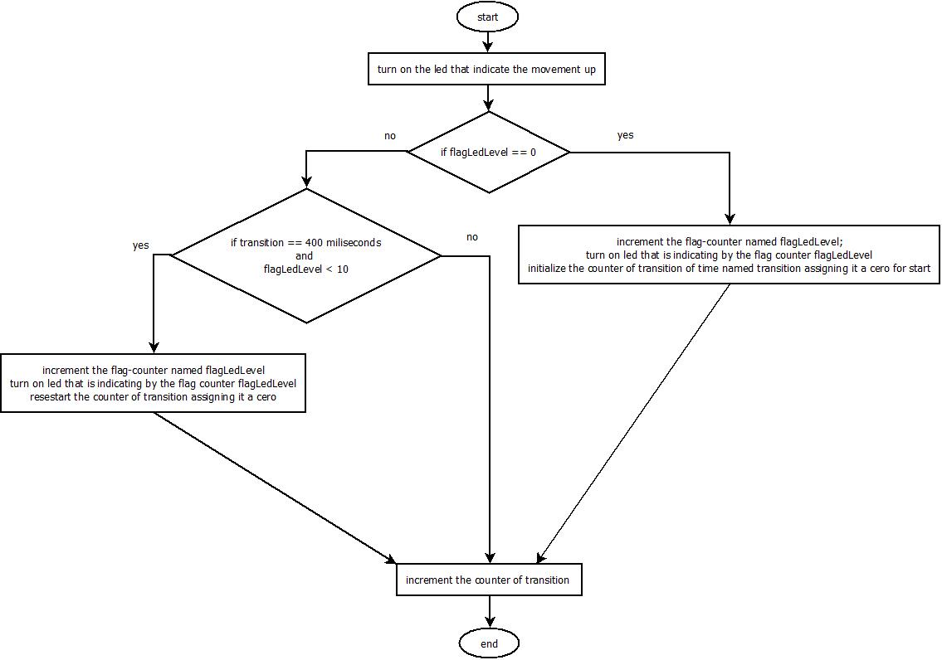

Function void turnOffLeds(void)
Description | It controls the turn off between each led respecting the time of each transition of 400 milliseconds
Parameter 1  <input| output| inout> | Void
Parameter 2..n | Void
Return Value | Void
Precondition | This function is called by the functions check_button_down() and check_button_antipinch()
Post condition
Error Conditions

Dynamic Behavior
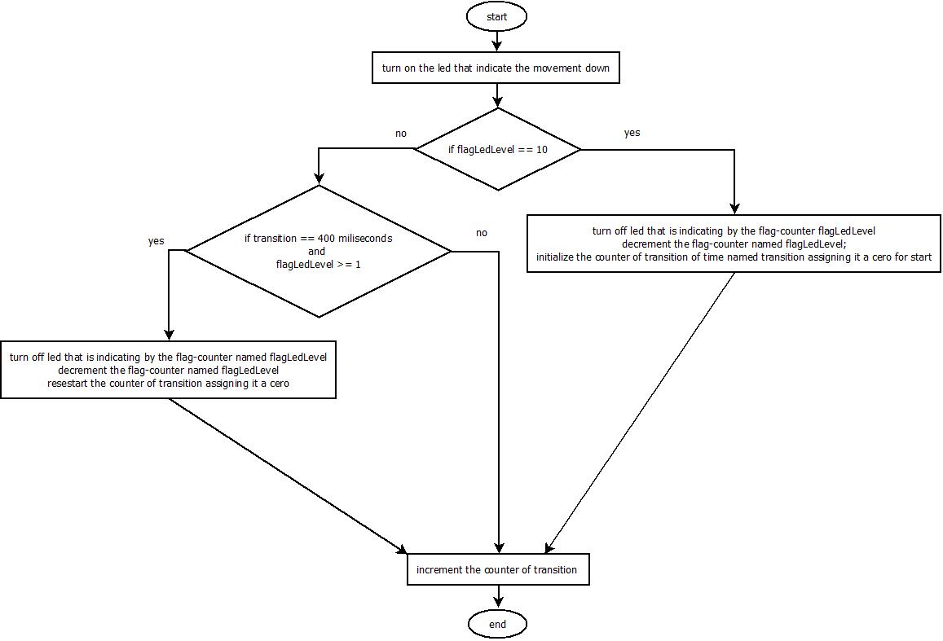

Function void turnLeds(T_UBYTE lub_led, T_UBYTE lub_mode)
Description | Turn on/off a specific Led
Parameter 1  <input| output| inout> | T_UBYTE lub_led represent the numer of LED
Parameter 2 | T_UBYTE lub_mode has two possibles values 0 and 10 represent turn off and 1 represent turn on
Return Value | Void
Precondition | This function is called by the functions turnOnLeds() and turnOffLeds()
Post condition
Error Conditions

Dynamic Behavior
